# Pandas Tutorial

Pandas is a Python library.

Pandas is used to analyze data.

## Learning by Reading

We have created 14 tutorial pages for you to learn more about Pandas.

Starting with a basic introduction and ends up with cleaning and plotting data:

### Basic

* Introduction
* Getting Started
* Pandas Series
* DataFrames
* Read CSV
* Read JSON
* Analyze Data

### Cleaning Data

* Clean Data
* Clean Empty Cells
* Clean Wrong Format
* Clean Wrong Data
* Remove Duplicates

### Advanced

* Correlations
* Plotting

### Example

Load a CSV file into a Pandas DataFrame:

import pandas as pd  
  
df = pd.read_csv('data.csv')  
  
print(df.to_string())

# Pandas Introduction

## What is Pandas?

Pandas is a Python library used for working with data sets.

It has functions for analyzing, cleaning, exploring, and manipulating data.

The name "Pandas" has a reference to both "Panel Data", and "Python Data Analysis" and was created by Wes McKinney in 2008.

## Why Use Pandas?

Pandas allows us to analyze big data and make conclusions based on statistical theories.

Pandas can clean messy data sets, and make them readable and relevant.

Relevant data is very important in data science.

Data Science: is a branch of computer science where we study how to store, use and analyze data for deriving information from it.

## What Can Pandas Do?

Pandas gives you answers about the data. Like:

* Is there a correlation between two or more columns?
* What is average value?
* Max value?
* Min value?

Pandas are also able to delete rows that are not relevant, or contains wrong values, like empty or NULL values. This is called cleaning the data.

## Where is the Pandas Codebase?

The source code for Pandas is located at this github repository https://github.com/pandas-dev/pandas

github: enables many people to work on the same codebase.

# Pandas Getting Started

## Installation of Pandas

If you have [Python](https://www.w3schools.com/python/default.asp) and [PIP](https://www.w3schools.com/python/python_pip.asp) already installed on a system, then installation of Pandas is very easy.

Install it using this command:

C:\Users\Your Name>pip install pandas

If this command fails, then use a python distribution that already has Pandas installed like, Anaconda, Spyder etc.

## Import Pandas

Once Pandas is installed, import it in your applications by adding the import keyword:

import pandas

Now Pandas is imported and ready to use.

### Example

import pandas  
mydataset = {  
 'cars': ["BMW", "Volvo", "Ford"],   
 'passings': [3, 7, 2]  
}  
myvar = pandas.DataFrame(mydataset)  
print(myvar)

## Pandas as pd

Pandas is usually imported under the pd alias.

alias: In Python alias are an alternate name for referring to the same thing.

Create an alias with the as keyword while importing:

import pandas as pd

Now the Pandas package can be referred to as pd instead of pandas.

### Example

import pandas as pd   
mydataset = {  
 'cars': ["BMW", "Volvo", "Ford"],   
 'passings': [3, 7, 2]  
}  
myvar = pd.DataFrame(mydataset)  
print(myvar)

## Checking Pandas Version

The version string is stored under __version__ attribute.

### Example

import pandas as pd  
print(pd.__version__)

# Pandas Series

## What is a Series?

A Pandas Series is like a column in a table.

It is a one-dimensional array holding data of any type.

### Example

Create a simple Pandas Series from a list:

import pandas as pd   
a = [1, 7, 2]  
myvar = pd.Series(a)  
print(myvar)

## Labels

If nothing else is specified, the values are labeled with their index number. First value has index 0, second value has index 1 etc.

This label can be used to access a specified value.

### Example

Return the first value of the Series:

print(myvar[0])

## Create Labels

With the index argument, you can name your own labels.

### Example

Create you own labels:

import pandas as pd   
a = [1, 7, 2]  
myvar = pd.Series(a, index = ["x", "y", "z"])  
print(myvar)

When you have created labels, you can access an item by referring to the label.

### Example

Return the value of "y":

print(myvar["y"])

## Key/Value Objects as Series

You can also use a key/value object, like a dictionary, when creating a Series.

### Example

Create a simple Pandas Series from a dictionary:

import pandas as pd   
calories = {"day1": 420, "day2": 380, "day3": 390}  
myvar = pd.Series(calories)  
print(myvar)

Note: The keys of the dictionary become the labels.

To select only some of the items in the dictionary, use the index argument and specify only the items you want to include in the Series.

### Example

Create a Series using only data from "day1" and "day2":

import pandas as pd   
calories = {"day1": 420, "day2": 380, "day3": 390}  
myvar = pd.Series(calories, index = ["day1", "day2"])  
print(myvar)

## DataFrames

Data sets in Pandas are usually multi-dimensional tables, called DataFrames.

Series is like a column, a DataFrame is the whole table.

### Example

Create a DataFrame from two Series:

import pandas as pd   
data = {  
 "calories": [420, 380, 390],  
 "duration": [50, 40, 45]  
}  
myvar = pd.DataFrame(data)  
print(myvar)

# Pandas DataFrames

## What is a DataFrame?

A Pandas DataFrame is a 2 dimensional data structure, like a 2 dimensional array, or a table with rows and columns.

### Example

Create a simple Pandas DataFrame:

import pandas as pd   
data = {  
 "calories": [420, 380, 390],  
 "duration": [50, 40, 45]  
}  
#load data into a DataFrame object:  
df = pd.DataFrame(data)  
print(df)

## Result

calories duration

0 420 50

1 380 40

2 390 45

## Locate Row

As you can see from the result above, the DataFrame is like a table with rows and columns.

Pandas use the loc attribute to return one or more specified row(s)

### Example

Return row 0:

#refer to the row index:  
print(df.loc[0])

## Result

calories 420

duration 50

Name: 0, dtype: int64

Note: This example returns a Pandas Series.

### Example

Return row 0 and 1:

#use a list of indexes:  
print(df.loc[[0, 1]])

## Result

calories duration

0 420 50

1 380 40

Note: When using [], the result is a Pandas DataFrame.

## Named Indexes

With the index argument, you can name your own indexes.

### Example

Add a list of names to give each row a name:

import pandas as pd   
data = {  
 "calories": [420, 380, 390],  
 "duration": [50, 40, 45]  
}  
df = pd.DataFrame(data, index = ["day1", "day2", "day3"])  
print(df)

## Result

calories duration

day1 420 50

day2 380 40

day3 390 45

## Locate Named Indexes

Use the named index in the loc attribute to return the specified row(s).

### Example

Return "day2":

#refer to the named index:  
print(df.loc["day2"])

## Result

calories 380

duration 40

Name: 0, dtype: int64

## Load Files Into a DataFrame

If your data sets are stored in a file, Pandas can load them into a DataFrame.

### Example

Load a comma separated file (CSV file) into a DataFrame:

import pandas as pd  
df = pd.read_csv('data.csv')  
print(df)

# Pandas Read CSV

## Read CSV Files

A simple way to store big data sets is to use CSV files (comma separated files).

CSV files contains plain text and is a well know format that can be read by everyone including Pandas.

In our examples we will be using a CSV file called 'data.csv'.

[Download data.csv](https://www.w3schools.com/python/pandas/data.csv). or [Open data.csv](https://www.w3schools.com/python/pandas/data.csv.txt)

### Example

Load the CSV into a DataFrame:

import pandas as pd  
df = pd.read_csv('data.csv')  
print(df.to_string())

Tip: use to_string() to print the entire DataFrame.

If you have a large DataFrame with many rows, Pandas will only return the first 5 rows, and the last 5 rows:

### Example

Print the DataFrame without the to_string() method:

import pandas as pd  
df = pd.read_csv('data.csv')  
print(df)

## max_rows

The number of rows returned is defined in Pandas option settings.

You can check your system's maximum rows with the pd.options.display.max_rows statement.

### Example

Check the number of maximum returned rows:

import pandas as pd  
  
print(pd.options.display.max_rows)

In my system the number is 60, which means that if the DataFrame contains more than 60 rows, the print(df) statement will return only the headers and the first and last 5 rows.

You can change the maximum rows number with the same statement.

### Example

Increase the maximum number of rows to display the entire DataFrame:

import pandas as pd  
pd.options.display.max_rows = 9999  
df = pd.read_csv('data.csv')  
print(df)

# Pandas Read JSON

## Read JSON

Big data sets are often stored, or extracted as JSON.

JSON is plain text, but has the format of an object, and is well known in the world of programming, including Pandas.

In our examples we will be using a JSON file called 'data.json'.

[Open data.json](https://www.w3schools.com/python/pandas/data.js).

### Example

Load the JSON file into a DataFrame:

import pandas as pd  
  
df = pd.read_json('data.json')  
  
print(df.to_string())

Tip: use to_string() to print the entire DataFrame.

## Dictionary as JSON

JSON = Python Dictionary

JSON objects have the same format as Python dictionaries.

If your JSON code is not in a file, but in a Python Dictionary, you can load it into a DataFrame directly:

### Example

Load a Python Dictionary into a DataFrame:

import pandas as pd  
  
data = {  
 "Duration":{  
 "0":60,  
 "1":60,  
 "2":60,  
 "3":45,  
 "4":45,  
 "5":60  
 },  
 "Pulse":{  
 "0":110,  
 "1":117,  
 "2":103,  
 "3":109,  
 "4":117,  
 "5":102  
 },  
 "Maxpulse":{  
 "0":130,  
 "1":145,  
 "2":135,  
 "3":175,  
 "4":148,  
 "5":127  
 },  
 "Calories":{  
 "0":409,  
 "1":479,  
 "2":340,  
 "3":282,  
 "4":406,  
 "5":300  
 }  
}  
  
df = pd.DataFrame(data)  
  
print(df)

# Pandas - Analyzing DataFrames

## Viewing the Data

One of the most used method for getting a quick overview of the DataFrame, is the head() method.

The head() method returns the headers and a specified number of rows, starting from the top.

### Example

Get a quick overview by printing the first 10 rows of the DataFrame:

import pandas as pd  
  
df = pd.read_csv('data.csv')  
  
print(df.head(10))

In our examples we will be using a CSV file called 'data.csv'.

Download [data.csv](https://www.w3schools.com/python/pandas/data.csv), or open [data.csv](https://www.w3schools.com/python/pandas/data.csv.txt) in your browser.

Note: if the number of rows is not specified, the head() method will return the top 5 rows.

### Example

Print the first 5 rows of the DataFrame:

import pandas as pd  
  
df = pd.read_csv('data.csv')  
  
print(df.head())

There is also a tail() method for viewing the last rows of the DataFrame.

The tail() method returns the headers and a specified number of rows, starting from the bottom.

### Example

Print the last 5 rows of the DataFrame:

print(df.tail())

## Info About the Data

The DataFrames object has a method called info(), that gives you more information about the data set.

### Example

Print information about the data:

print(df.info())

## Result

<class 'pandas.core.frame.DataFrame'>

RangeIndex: 169 entries, 0 to 168

Data columns (total 4 columns):

# Column Non-Null Count Dtype

--- ------ -------------- -----

0 Duration 169 non-null int64

1 Pulse 169 non-null int64

2 Maxpulse 169 non-null int64

3 Calories 164 non-null float64

dtypes: float64(1), int64(3)

memory usage: 5.4 KB

None

## Result Explained

The result tells us there are 169 rows and 4 columns:

RangeIndex: 169 entries, 0 to 168

Data columns (total 4 columns):

And the name of each column, with the data type:

# Column Non-Null Count Dtype

--- ------ -------------- -----

0 Duration 169 non-null int64

1 Pulse 169 non-null int64

2 Maxpulse 169 non-null int64

3 Calories 164 non-null float64

## Null Values

The info() method also tells us how many Non-Null values there are present in each column, and in our data set it seems like there are 164 of 169 Non-Null values in the "Calories" column.

Which means that there are 5 rows with no value at all, in the "Calories" column, for whatever reason.

Empty values, or Null values, can be bad when analyzing data, and you should consider removing rows with empty values. This is a step towards what is called cleaning data, and you will learn more about that in the next chapters.

# Pandas - Cleaning Data

## Data Cleaning

Data cleaning means fixing bad data in your data set.

Bad data could be:

* Empty cells
* Data in wrong format
* Wrong data
* Duplicates

In this tutorial you will learn how to deal with all of them.

## Our Data Set

In the next chapters we will use this data set:

Duration Date Pulse Maxpulse Calories

0 60 '2020/12/01' 110 130 409.1

1 60 '2020/12/02' 117 145 479.0

2 60 '2020/12/03' 103 135 340.0

3 45 '2020/12/04' 109 175 282.4

4 45 '2020/12/05' 117 148 406.0

5 60 '2020/12/06' 102 127 300.0

6 60 '2020/12/07' 110 136 374.0

7 450 '2020/12/08' 104 134 253.3

8 30 '2020/12/09' 109 133 195.1

9 60 '2020/12/10' 98 124 269.0

10 60 '2020/12/11' 103 147 329.3

11 60 '2020/12/12' 100 120 250.7

12 60 '2020/12/12' 100 120 250.7

13 60 '2020/12/13' 106 128 345.3

14 60 '2020/12/14' 104 132 379.3

15 60 '2020/12/15' 98 123 275.0

16 60 '2020/12/16' 98 120 215.2

17 60 '2020/12/17' 100 120 300.0

18 45 '2020/12/18' 90 112 NaN

19 60 '2020/12/19' 103 123 323.0

20 45 '2020/12/20' 97 125 243.0

21 60 '2020/12/21' 108 131 364.2

22 45 NaN 100 119 282.0

23 60 '2020/12/23' 130 101 300.0

24 45 '2020/12/24' 105 132 246.0

25 60 '2020/12/25' 102 126 334.5

26 60 2020/12/26 100 120 250.0

27 60 '2020/12/27' 92 118 241.0

28 60 '2020/12/28' 103 132 NaN

29 60 '2020/12/29' 100 132 280.0

30 60 '2020/12/30' 102 129 380.3

31 60 '2020/12/31' 92 115 243.0

The data set contains some empty cells ("Date" in row 22, and "Calories" in row 18 and 28).

The data set contains wrong format ("Date" in row 26).

The data set contains wrong data ("Duration" in row 7).

The data set contains duplicates (row 11 and 12).

# Pandas - Cleaning Empty Cells

## Empty Cells

Empty cells can potentially give you a wrong result when you analyze data.

## Remove Rows

One way to deal with empty cells is to remove rows that contain empty cells.

This is usually OK, since data sets can be very big, and removing a few rows will not have a big impact on the result.

### Example

Return a new Data Frame with no empty cells:

import pandas as pd  
  
df = pd.read_csv('data.csv')  
  
new_df = df.dropna()  
  
print(new_df.to_string())

In our cleaning examples we will be using a CSV file called 'dirtydata.csv'.

[Download dirtydata.csv](https://www.w3schools.com/python/pandas/dirtydata.csv). or [Open dirtydata.csv](https://www.w3schools.com/python/pandas/dirtydata.csv.txt)

Note: By default, the dropna() method returns a new DataFrame, and will not change the original.

If you want to change the original DataFrame, use the inplace = True argument:

### Example

Remove all rows with NULL values:

import pandas as pd  
  
df = pd.read_csv('data.csv')  
  
df.dropna(inplace = True)  
  
print(df.to_string())

Note: Now, the dropna(inplace = True) will NOT return a new DataFrame, but it will remove all rows containg NULL values from the original DataFrame.

## Replace Empty Values

Another way of dealing with empty cells is to insert a new value instead.

This way you do not have to delete entire rows just because of some empty cells.

The fillna() method allows us to replace empty cells with a value:

### Example

Replace NULL values with the number 130:

import pandas as pd  
  
df = pd.read_csv('data.csv')  
  
df.fillna(130, inplace = True)

### Replace Only For Specified Columns

The example above replaces all empty cells in the whole Data Frame.

To only replace empty values for one column, specify the column name for the DataFrame:

### Example

Replace NULL values in the "Calories" columns with the number 130:

import pandas as pd  
  
df = pd.read_csv('data.csv')  
  
df["Calories"].fillna(130, inplace = True)

## Replace Using Mean, Median, or Mode

A common way to replace empty cells, is to calculate the mean, median or mode value of the column.

Pandas uses the mean() median() and mode() methods to calculate the respective values for a specified column:

### Example

Calculate the MEAN, and replace any empty values with it:

import pandas as pd  
  
df = pd.read_csv('data.csv')  
  
x = df["Calories"].mean()  
  
df["Calories"].fillna(x, inplace = True)

Mean = the average value (the sum of all values divided by number of values).

### Example

Calculate the MEDIAN, and replace any empty values with it:

import pandas as pd  
  
df = pd.read_csv('data.csv')  
  
x = df["Calories"].median()  
  
df["Calories"].fillna(x, inplace = True)

Median = the value in the middle, after you have sorted all values ascending.

### Example

Calculate the MODE, and replace any empty values with it:

import pandas as pd  
  
df = pd.read_csv('data.csv')  
  
x = df["Calories"].mode()[0]  
  
df["Calories"].fillna(x, inplace = True)

Mode = the value that appears most frequently.

# Pandas - Cleaning Data of Wrong Format

## Data of Wrong Format

Cells with data of wrong format can make it difficult, or even impossible, to analyze data.

To fix it, you have two options: remove the rows, or convert all cells in the columns into the same format.

## Convert Into a Correct Format

In our Data Frame, we have two cells with the wrong format. Check out row 22 and 26, the 'Date' column should be a string that represents a date:

Duration Date Pulse Maxpulse Calories

0 60 '2020/12/01' 110 130 409.1

1 60 '2020/12/02' 117 145 479.0

2 60 '2020/12/03' 103 135 340.0

3 45 '2020/12/04' 109 175 282.4

4 45 '2020/12/05' 117 148 406.0

5 60 '2020/12/06' 102 127 300.0

6 60 '2020/12/07' 110 136 374.0

7 450 '2020/12/08' 104 134 253.3

8 30 '2020/12/09' 109 133 195.1

9 60 '2020/12/10' 98 124 269.0

10 60 '2020/12/11' 103 147 329.3

11 60 '2020/12/12' 100 120 250.7

12 60 '2020/12/12' 100 120 250.7

13 60 '2020/12/13' 106 128 345.3

14 60 '2020/12/14' 104 132 379.3

15 60 '2020/12/15' 98 123 275.0

16 60 '2020/12/16' 98 120 215.2

17 60 '2020/12/17' 100 120 300.0

18 45 '2020/12/18' 90 112 NaN

19 60 '2020/12/19' 103 123 323.0

20 45 '2020/12/20' 97 125 243.0

21 60 '2020/12/21' 108 131 364.2

22 45 NaN 100 119 282.0

23 60 '2020/12/23' 130 101 300.0

24 45 '2020/12/24' 105 132 246.0

25 60 '2020/12/25' 102 126 334.5

26 60 20201226 100 120 250.0

27 60 '2020/12/27' 92 118 241.0

28 60 '2020/12/28' 103 132 NaN

29 60 '2020/12/29' 100 132 280.0

30 60 '2020/12/30' 102 129 380.3

31 60 '2020/12/31' 92 115 243.0

Let's try to convert all cells in the 'Date' column into dates.

Pandas has a to_datetime() method for this:

### Example

Convert to date:

import pandas as pd  
  
df = pd.read_csv('data.csv')  
  
df['Date'] = pd.to_datetime(df['Date'])  
  
print(df.to_string())

**Result:**

Duration Date Pulse Maxpulse Calories

0 60 '2020/12/01' 110 130 409.1

1 60 '2020/12/02' 117 145 479.0

2 60 '2020/12/03' 103 135 340.0

3 45 '2020/12/04' 109 175 282.4

4 45 '2020/12/05' 117 148 406.0

5 60 '2020/12/06' 102 127 300.0

6 60 '2020/12/07' 110 136 374.0

7 450 '2020/12/08' 104 134 253.3

8 30 '2020/12/09' 109 133 195.1

9 60 '2020/12/10' 98 124 269.0

10 60 '2020/12/11' 103 147 329.3

11 60 '2020/12/12' 100 120 250.7

12 60 '2020/12/12' 100 120 250.7

13 60 '2020/12/13' 106 128 345.3

14 60 '2020/12/14' 104 132 379.3

15 60 '2020/12/15' 98 123 275.0

16 60 '2020/12/16' 98 120 215.2

17 60 '2020/12/17' 100 120 300.0

18 45 '2020/12/18' 90 112 NaN

19 60 '2020/12/19' 103 123 323.0

20 45 '2020/12/20' 97 125 243.0

21 60 '2020/12/21' 108 131 364.2

22 45 NaT 100 119 282.0

23 60 '2020/12/23' 130 101 300.0

24 45 '2020/12/24' 105 132 246.0

25 60 '2020/12/25' 102 126 334.5

26 60 '2020/12/26' 100 120 250.0

27 60 '2020/12/27' 92 118 241.0

28 60 '2020/12/28' 103 132 NaN

29 60 '2020/12/29' 100 132 280.0

30 60 '2020/12/30' 102 129 380.3

31 60 '2020/12/31' 92 115 243.0

As you can see from the result, the date in row 26 was fixed, but the empty date in row 22 got a NaT (Not a Time) value, in other words an empty value. One way to deal with empty values is simply removing the entire row.

## Removing Rows

The result from the converting in the example above gave us a NaT value, which can be handled as a NULL value, and we can remove the row by using the dropna() method.

### Example

Remove rows with a NULL value in the "Date" column:

df.dropna(subset=['Date'], inplace = True)

# Pandas - Fixing Wrong Data

## Wrong Data

"Wrong data" does not have to be "empty cells" or "wrong format", it can just be wrong, like if someone registered "199" instead of "1.99".

Sometimes you can spot wrong data by looking at the data set, because you have an expectation of what it should be.

If you take a look at our data set, you can see that in row 7, the duration is 450, but for all the other rows the duration is between 30 and 60.

It doesn't have to be wrong, but taking in consideration that this is the data set of someone's workout sessions, we conclude with the fact that this person did not work out in 450 minutes.

Duration Date Pulse Maxpulse Calories

0 60 '2020/12/01' 110 130 409.1

1 60 '2020/12/02' 117 145 479.0

2 60 '2020/12/03' 103 135 340.0

3 45 '2020/12/04' 109 175 282.4

4 45 '2020/12/05' 117 148 406.0

5 60 '2020/12/06' 102 127 300.0

6 60 '2020/12/07' 110 136 374.0

7 450 '2020/12/08' 104 134 253.3

8 30 '2020/12/09' 109 133 195.1

9 60 '2020/12/10' 98 124 269.0

10 60 '2020/12/11' 103 147 329.3

11 60 '2020/12/12' 100 120 250.7

12 60 '2020/12/12' 100 120 250.7

13 60 '2020/12/13' 106 128 345.3

14 60 '2020/12/14' 104 132 379.3

15 60 '2020/12/15' 98 123 275.0

16 60 '2020/12/16' 98 120 215.2

17 60 '2020/12/17' 100 120 300.0

18 45 '2020/12/18' 90 112 NaN

19 60 '2020/12/19' 103 123 323.0

20 45 '2020/12/20' 97 125 243.0

21 60 '2020/12/21' 108 131 364.2

22 45 NaN 100 119 282.0

23 60 '2020/12/23' 130 101 300.0

24 45 '2020/12/24' 105 132 246.0

25 60 '2020/12/25' 102 126 334.5

26 60 20201226 100 120 250.0

27 60 '2020/12/27' 92 118 241.0

28 60 '2020/12/28' 103 132 NaN

29 60 '2020/12/29' 100 132 280.0

30 60 '2020/12/30' 102 129 380.3

31 60 '2020/12/31' 92 115 243.0

How can we fix wrong values, like the one for "Duration" in row 7?

## Replacing Values

One way to fix wrong values is to replace them with something else.

In our example, it is most likely a typo, and the value should be "45" instead of "450", and we could just insert "45" in row 7:

### Example

Set "Duration" = 45 in row 7:

df.loc[7, 'Duration'] = 45

For small data sets you might be able to replace the wrong data one by one, but not for big data sets.

To replace wrong data for larger data sets you can create some rules, e.g. set some boundaries for legal values, and replace any values that are outside of the boundaries.

### Example

Loop through all values in the "Duration" column.

If the value is higher than 120, set it to 120:

for x in df.index:   
 if df.loc[x, "Duration"] > 120:  
 df.loc[x, "Duration"] = 120

## Removing Rows

Another way of handling wrong data is to remove the rows that contains wrong data.

This way you do not have to find out what to replace them with, and there is a good chance you do not need them to do your analyses.

### Example

Delete rows where "Duration" is higher than 120:

for x in df.index:   
 if df.loc[x, "Duration"] > 120:  
 df.drop(x, inplace = True)

# Pandas - Removing Duplicates

## Discovering Duplicates

Duplicate rows are rows that have been registered more than one time.

Duration Date Pulse Maxpulse Calories

0 60 '2020/12/01' 110 130 409.1

1 60 '2020/12/02' 117 145 479.0

2 60 '2020/12/03' 103 135 340.0

3 45 '2020/12/04' 109 175 282.4

4 45 '2020/12/05' 117 148 406.0

5 60 '2020/12/06' 102 127 300.0

6 60 '2020/12/07' 110 136 374.0

7 450 '2020/12/08' 104 134 253.3

8 30 '2020/12/09' 109 133 195.1

9 60 '2020/12/10' 98 124 269.0

10 60 '2020/12/11' 103 147 329.3

11 60 '2020/12/12' 100 120 250.7

12 60 '2020/12/12' 100 120 250.7

13 60 '2020/12/13' 106 128 345.3

14 60 '2020/12/14' 104 132 379.3

15 60 '2020/12/15' 98 123 275.0

16 60 '2020/12/16' 98 120 215.2

17 60 '2020/12/17' 100 120 300.0

18 45 '2020/12/18' 90 112 NaN

19 60 '2020/12/19' 103 123 323.0

20 45 '2020/12/20' 97 125 243.0

21 60 '2020/12/21' 108 131 364.2

22 45 NaN 100 119 282.0

23 60 '2020/12/23' 130 101 300.0

24 45 '2020/12/24' 105 132 246.0

25 60 '2020/12/25' 102 126 334.5

26 60 20201226 100 120 250.0

27 60 '2020/12/27' 92 118 241.0

28 60 '2020/12/28' 103 132 NaN

29 60 '2020/12/29' 100 132 280.0

30 60 '2020/12/30' 102 129 380.3

31 60 '2020/12/31' 92 115 243.0

By taking a look at our test data set, we can assume that row 11 and 12 are duplicates.

To discover duplicates, we can use the duplicated() method.

The duplicated() method returns a Boolean values for each row:

### Example

Returns True for every row that is a duplicate, othwerwise False:

print(df.duplicated())

## Removing Duplicates

To remove duplicates, use the drop_duplicates() method.

### Example

Remove all duplicates:

df.drop_duplicates(inplace = True)

Remember: The (inplace = True) will make sure that the method does NOT return a new DataFrame, but it will remove all duplicates from the original DataFrame.

# Pandas - Data Correlations

## Finding Relationships

A great aspect of the Pandas module is the corr() method.

The corr() method calculates the relationship between each column in your data set.

The examples in this page uses a CSV file called: 'data.csv'.

[Download data.csv](https://www.w3schools.com/python/pandas/data.csv). or [Open data.csv](https://www.w3schools.com/python/pandas/data.csv.txt)

### Example

Show the relationship between the columns:

df.corr()

### Result

Duration Pulse Maxpulse Calories

Duration 1.000000 -0.155408 0.009403 0.922721

Pulse -0.155408 1.000000 0.786535 0.025120

Maxpulse 0.009403 0.786535 1.000000 0.203814

Calories 0.922721 0.025120 0.203814 1.000000

Note: The corr() method ignores "not numeric" columns.

### Result Explained

The Result of the corr() method is a table with a lot of numbers that represents how well the relationship is between two columns.

The number varies from -1 to 1.

1 means that there is a 1 to 1 relationship (a perfect correlation), and for this data set, each time a value went up in the first column, the other one went up as well.

0.9 is also a good relationship, and if you increase one value, the other will probably increase as well.

-0.9 would be just as good relationship as 0.9, but if you increase one value, the other will probably go down.

0.2 means NOT a good relationship, meaning that if one value goes up does not mean that the other will.

What is a good correlation? It depends on the use, but I think it is safe to say you have to have at least 0.6 (or -0.6) to call it a good correlation.

### Perfect Correlation:

We can see that "Duration" and "Duration" got the number 1.000000, which makes sense, each column always has a perfect relationship with itself.

### Good Correlation:

"Duration" and "Calories" got a 0.922721 correlation, which is a very good correlation, and we can predict that the longer you work out, the more calories you burn, and the other way around: if you burned a lot of calories, you probably had a long work out.

### Bad Correlation:

"Duration" and "Maxpulse" got a 0.009403 correlation, which is a very bad correlation, meaning that we can not predict the max pulse by just looking at the duration of the work out, and vice versa.

# Pandas - Plotting

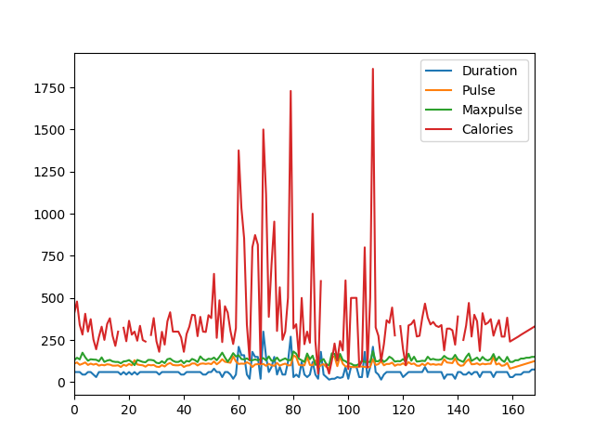

## Plotting

Pandas uses the plot() method to create diagrams.

We can use Pyplot, a submodule of the Matplotlib library to visualize the diagram on the screen.

Read more about Matplotlib in our [Matplotlib Tutorial](https://www.w3schools.com/python/matplotlib_intro.asp).

### Example

Import pyplot from Matplotlib and visualize our DataFrame:

import pandas as pd  
import matplotlib.pyplot as plt  
  
df = pd.read_csv('data.csv')  
  
df.plot()  
  
plt.show()

The examples in this page uses a CSV file called: 'data.csv'.

[Download data.csv](https://www.w3schools.com/python/pandas/data.csv) or [Open data.csv](https://www.w3schools.com/python/pandas/data.csv.txt)

## Scatter Plot

Specify that you want a scatter plot with the kind argument:

kind = 'scatter'

A scatter plot needs an x- and a y-axis.

In the example below we will use "Duration" for the x-axis and "Calories" for the y-axis.

Include the x and y arguments like this:

x = 'Duration', y = 'Calories'

### Example

import pandas as pd  
import matplotlib.pyplot as plt  
  
df = pd.read_csv('data.csv')  
  
df.plot(kind = 'scatter', x = 'Duration', y = 'Calories')  
  
plt.show()

### Result

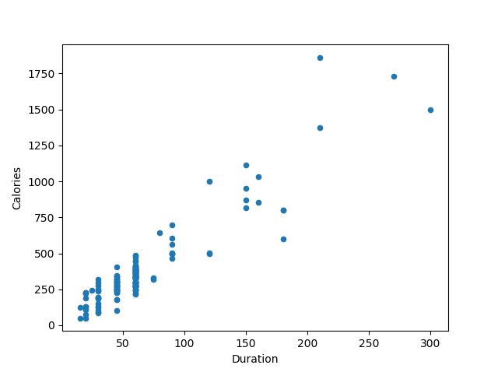

Remember: In the previous example, we learned that the correlation between "Duration" and "Calories" was 0.922721, and we conluded with the fact that higher duration means more calories burned.

By looking at the scatterplot, I will agree.

Let's create another scatterplot, where there is a bad relationship between the columns, like "Duration" and "Maxpulse", with the correlation 0.009403:

### Example

A scatterplot where there are no relationship between the columns:

import pandas as pd  
import matplotlib.pyplot as plt  
  
df = pd.read_csv('data.csv')  
  
df.plot(kind = 'scatter', x = 'Duration', y = 'Maxpulse')  
  
plt.show()

### Result

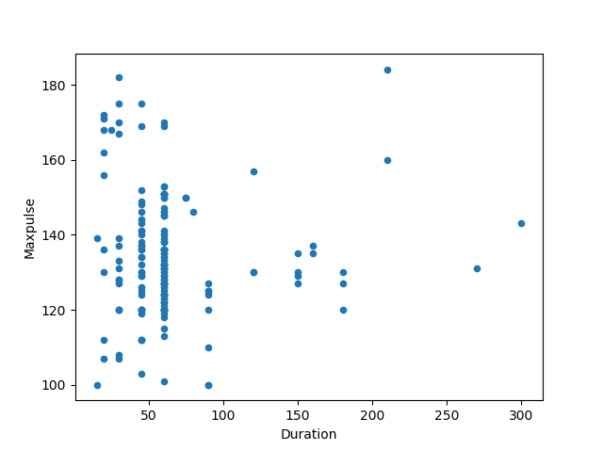

## Histogram

Use the kind argument to specify that you want a histogram:

kind = 'hist'

A histogram needs only one column.

A histogram shows us the frequency of each interval, e.g. how many workouts lasted between 50 and 60 minutes?

In the example below we will use the "Duration" column to create the histogram:

### Example

df["Duration"].plot(kind = 'hist')

### Result

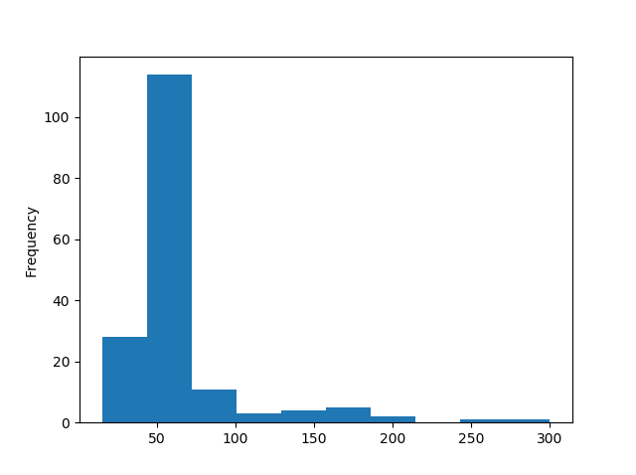

Note: The histogram tells us that there were over 100 workouts that lasted between 50 and 60 minutes.